1. (TCP) When would TCP execute delayed ACK? Why? (4 pts) [3-4, slide 7]

This is not the same as cumulative ack. This is done to make sure that there are no more packets arriving. After a set amount of time, the receiver can be reasonably sure that there are no more packets, and thus an ACK can be sent.

2. (TCP) When would TCP execute fast retransmit? Why? (4 pts) [3-4, slide 8]

TCP would execute fast retransmit if the sender receives 3 ACKs for the same data. This is done in order to not have to wait out the time-out period when we know for certain that there is a problem.

3. (TCP) Who (in terms of sender/receiver) initiates the flow control? How does the flow control work in TCP? (4 pts) [3-4, slide 11 and 12]

The receiver controls the sender, so that the sender won’t overflow the receiver’s buffer by transmitting too much, too fast. The receiver “advertises” free buffer space by including a rwnd value in TCP header of receiver-to-sender segments. The sender limits the amount of unacked data to receivers rwnd value.

4. (TCP) What is the purpose of 3-way handshaking in TCP? (2 pts) [3-4, slide 14]

This is done in order for the sender and receiver to agree to establish a connection. (Both know that the other is willing to establish a connection). This is also done in order to agree on connection parameters.

5. (TCP) Draw the diagram showing the SYN/ACK bits and the sequence/acknowledge numbers for the following communication. The sender first chose a sequence number 33 and plans to send out a message ”CIS430” to the receiver. The receiver chose a sequence number 55 after receiving the packet from the sender. (10 pts) Note: show all the messages – including the handshaking part and the message exchange part after handshaking for full credit. [3-4, slide 17]

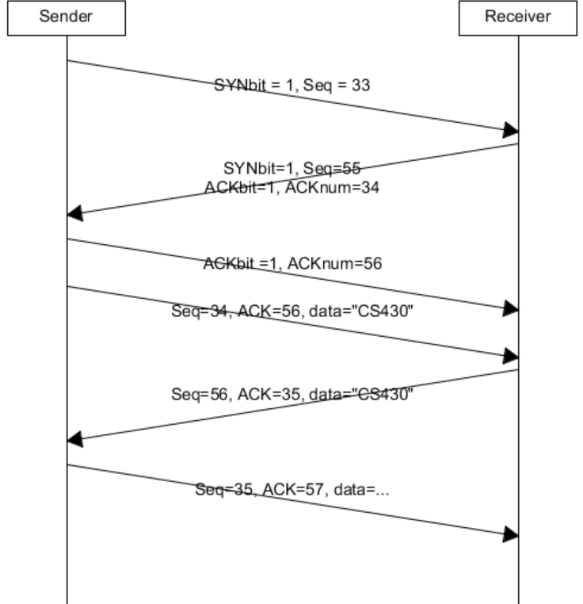

6. (TCP) Explain the reason why we don’t use a fixed round-trip time (RTT) in TCP.(4 pts)

The round trip time varies based on which path the messages take. If we set a value too short, we will have premature timeouts and unnecessary retransmissions. If we set a time too long, we will have segment loss.

7. (TCP) Given the following sample RTTs (R0 is the first sample RTT and you may consider it as the initial estimated RTT). Calculate the Estimated RTTs after taking each of the samples. Assume that the α=1/4. Note: show all steps to get full credit.(10 pts) [3-3, Slide 62]

EstimatedRTT = (1- α)*EstimatedRTT + α*SampleRTT

R0: = (1-0.25)*8 + (0.25*8) = 8

R1: (1-0.25)*8 + (0.25*24) = 12

R2: (1-0.25)*12 + (0.25*10) = 11.5

R3: (1-0.25)*11.5 + (0.25*8) = 10.625

|  |  |  |  |  |
| --- | --- | --- | --- | --- |
| Sample RTTs | R0 | R1 | R2 | R3 |
| Time | 8 | 24 | 10 | 8 |
| Calculated: | 8 | 12 | 11.5 | 10.625 |

8. How does TCP handle out-of-order segments on the receiver side? (2 pts)

(3-3, slide 59): TCP specifications does not say how receiver handles out-of-order segments, it is up to the implementor.

GBN: Discard the packet, re-ACK the packet with the highest in-order sequence number

Selective Repeat: buffer the packets

9. (TCP) For congestion avoidance, it is said to increment by 1 MSS after receiving newACK. Given the current cwnd = 4, show how it will be increment by 1 MSS after receiving the ACKs. (4 pts) [3-5, slide 18]

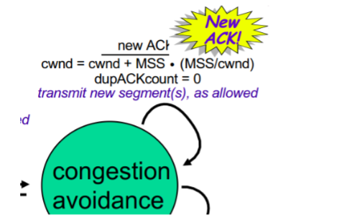

Cwnd = 4+1 *(1/4)

Cwnd = 4.25

If another one comes in:

Cwnd = 4.25 + 1(1/4.25)

Cwnd = 4.5 = ~4.49

10. What is the difference between goodput and throughput? (2 pts)

Throughput is the rate at which all data traverses a link, goodput is the rate at which useful data traverses a link.

11. (IPv4) In classful addressing, what are the classes for the following addresses?

(a)140.113.3.2 - Class B

(b) 13.8.2.232 - Class A

(c) 220.3.10.261 – Class C

(3 pts)Ref: Classful network

Class A

0. 0. 0. 0 = 00000000.00000000.00000000.00000000

127.255.255.255 = 01111111.11111111.11111111.11111111

0nnnnnnn.HHHHHHHH.HHHHHHHH.HHHHHHHH

Class B

128. 0. 0. 0 = 10000000.00000000.00000000.00000000

191.255.255.255 = 10111111.11111111.11111111.11111111

10nnnnnn.nnnnnnnn.HHHHHHHH.HHHHHHHH

Class C

192. 0. 0. 0 = 11000000.00000000.00000000.00000000

223.255.255.255 = 11011111.11111111.11111111.11111111

110nnnnn.nnnnnnnn.nnnnnnnn.HHHHHHHH

Class D

224. 0. 0. 0 = 11100000.00000000.00000000.00000000

239.255.255.255 = 11101111.11111111.11111111.11111111

1110XXXX.XXXXXXXX.XXXXXXXX.XXXXXXXX

Class E

240. 0. 0. 0 = 11110000.00000000.00000000.00000000

255.255.255.255 = 11111111.11111111.11111111.11111111

1111XXXX.XXXXXXXX.XXXXXXXX.XXXXXXXX

12. (IPv4) How many Class B networks do we have? For each Class B network, how many valid IP addresses can we use? (4 pts)

There are 16,384 Class B networks. There are a total of 1,073,741,824 total addresses in Class B.

13. (IPv4) Assume that you are the network operator at AT&T and you manage a network 12.0.0.0/8. If you want to evenly divide the whole AT&T network into four equivalent size subnets,

(a) list the slash notation for the four subnets.

12.0.0.0/10

12.64.0.0/10

12.128.0.0/10

12.192.0.0/10

(b) What is the netmask for the four subnets? (6 pts)Ref: List of assigned /8 IPv4 address block

255.192.0.0 (I believe this is for every one)

14. (IPv4) Following the question above, three startup companies apply to you for blocks of at least 100, 50, and 20 IP address (companies 1, 2, and 3). Please help the companies to allocate their subnet. Note: the subnets should not overlap!! (10 pts)Ref: APNIC - Obtaining resources

100 addresses = 7-bit

12.0.0.0/25

This will give us addresses 12.0.0.0 to 12.0.0.127

50 addresses = 6-bit

12.0.0.128/26

This will give us addresses 12.0.0.128 to 12.0.0.191

20 addresses = 5-bit

12.0.0.192/27

This will give us addresses 12.0.0.192 to 12.0.0.223